**Multicloud with devops by veera nareshit**

**S3 static web hosting url using to access in route53 DNS**

****The bucket name same as our go daddy dns 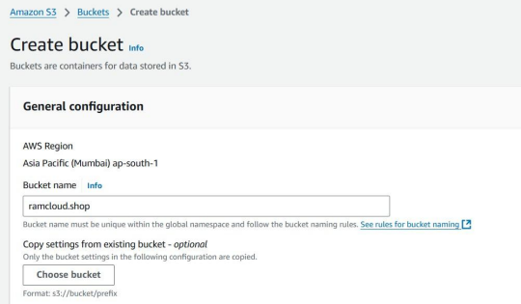

name

**Multicloud with devops by veera nareshit**

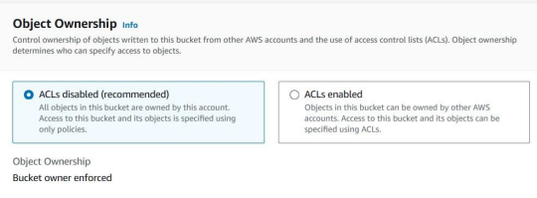

**Multicloud with devops by veera nareshit**

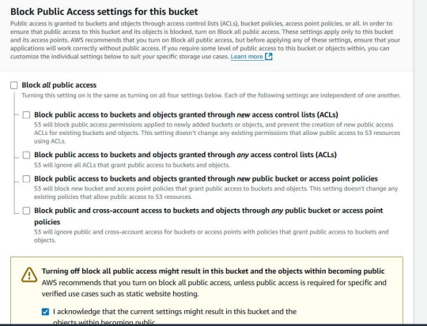**Multicloud with devops by veera nareshit**

**Multicloud with devops by veera nareshit**

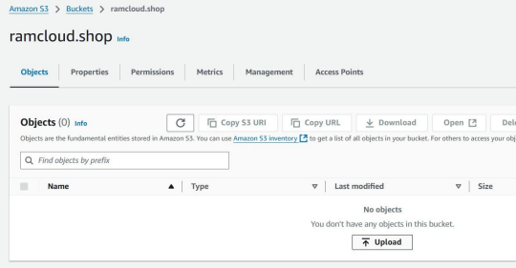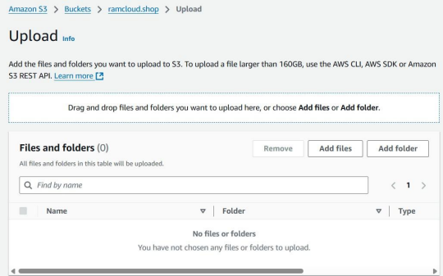

****•

**Multicloud with devops by veera nareshit**

**Multicloud with devops by veera nareshit Multicloud with devops by veera nareshit**

**Multicloud with devops by veera nareshit Multicloud with devops by veera nareshit**

**Multicloud with devops by veera nareshit **

**Multicloud with devops by veera nareshit**

**Multicloud with devops by veera nareshit Multicloud with devops by veera nareshit**

**Multicloud with devops by veera nareshit**

**Go to static website hosting and click edit**

**Multicloud with devops by veera nareshit**

**Multicloud with devops by veera nareshit Multicloud with devops by veera nareshit**

**Multicloud with devops by veera nareshit**

****•

**Multicloud with devops by veera nareshit**